

DBMS CORNERSTONE PROJECT

UNIVERSITY ACADEMIC MANAGEMENT
A Smart Database System for Managing University Academic Activities

Submitted by
Name | Roll Number
A. Pavan Kumar Reddy | 25B11AI052
G. Nikhilesh Varma | 25B11AI305
M. Revanth Yadav | 25B11AI670
N. Subhash | 25B11AI835


Department of Artificial Intelligence and Machine Learning
ADITYA UNIVERSITY
(Formerly Aditya Engineering College (A))
Aditya Nagar, ADB Road, Surampalem, Andhra Pradesh, India
Academic Year: 2026 – 2027

Aditya Nagar, ADB Road, Surampalem, Andhra Pradesh, India
DEPARTMENT OF ARTIFICIAL INTELLIGENCE AND MACHINE LEARNING
CERTIFICATE

This is to certify that the project report entitled “University Academic Management” is a bonafide record of the DBMS Cornerstone Project work carried out by the following students of the Department of Artificial Intelligence and Machine Learning, in partial fulfilment of the requirements of the course Database Management Systems.
A. Pavan Kumar Reddy (25B11AI052)
G. Nikhilesh Varma (25B11AI305)
M. Revanth Yadav (25B11AI670)
N. Subhash (25B11AI835)

Mr. M. Sudheer Dr. K. Naga Bhargavi
Project Guide Head of the Department

ACKNOWLEDGEMENT

We express our sincere gratitude to our project guide and the faculty of the Department of Artificial Intelligence and Machine Learning for their guidance, encouragement and constructive feedback throughout the DBMS Cornerstone Project.
We also thank the Head of the Department and the management of the institution for providing the facilities required to complete this work, and our team members for their cooperation and shared effort in designing, documenting and implementing the University Academic Management database.

— A. Pavan Kumar Reddy, G. Nikhilesh Varma, M. Revanth Yadav and N. Subhash

TABLE OF CONTENTS
LIST OF FIGURES 6
LIST OF TABLES 6
ACRONYMS 6
1. INTRODUCTION 8
1.1 Brief Information about the Project 8
1.2 Motivation and Contribution of the Project 8
1.3 Objectives of the Project 8
1.4 Scope of the Project 8
2. SYSTEM ANALYSIS 9
2.1 Existing System and Problem Statement 9
2.2 Proposed System 9
2.3 Functional Requirements 9
2.4 Non-Functional Requirements 9
2.5 Requirements Specification 10
3. DATABASE DESIGN 11
3.1 Major Entities 11
3.2 ER Model 11
3.3 Relationships 11
4. ER DIAGRAM 12
5. RELATIONAL SCHEMA 13
6. TABLE DESIGN 14
6.1 Department Table 14
6.2 Student Table 14
6.3 Staff Table 14
6.4 Course Table 14
6.5 Section Table 14
6.6 Enrollment Table 15
6.7 Primary Keys and Foreign Keys 15
6.8 Other Constraints 15
7. NORMALIZATION 17
7.1 Unnormalized Form (UNF) 17
7.2 First Normal Form (1NF) 17
7.3 Second Normal Form (2NF) 17
7.4 Third Normal Form (3NF) 17
8. SQL IMPLEMENTATION 18
8.1 DDL – Data Definition Language 18
8.2 Indexes 19
8.3 DML – Seed Data 19
9. SQL QUERIES & SCREENSHOTS 20
10. GITHUB REPOSITORY AND TEAM MEMBER RESPONSIBILITIES 36
10.1 GitHub Repository 36
10.2 Team Member Responsibilities 36
11. CONCLUSION 37
12. FUTURE ENHANCEMENTS 38
REFERENCES 38

ABSTRACT

The University Academic Management System is a centralized relational database designed to support core university functions such as admissions, registration, grading and payroll. Current departmental processes depend on fragmented spreadsheets and legacy systems, which leads to inconsistent student records, duplicate entries, poor visibility of enrolment counts and prerequisites, manual grade aggregation, error-prone payroll calculations and a limited audit trail for administrative changes.
This project models six core entities — Student, Staff, Course, Section, Enrollment and Department — using an ER diagram, converts the model into a normalized relational schema (up to Third Normal Form), and defines primary keys, foreign keys, unique constraints and indexes through SQL DDL. A minimal seed dataset and a set of sample queries are provided to validate the workflows for the capstone demonstration, and the project artefacts and migration steps are maintained in a GitHub repository.

LIST OF FIGURES
Figure 1. ER Diagram – University Academic Management System
Figure 2. Relational Database Schema – University Academic Management System

LIST OF TABLES
Table 1. Major Database Entities
Table 2. Relationships between Entities
Table 3. Department Table Structure
Table 4. Student Table Structure
Table 5. Staff Table Structure
Table 6. Course Table Structure
Table 7. Section Table Structure
Table 8. Enrollment Table Structure
Table 9. Primary Keys and Foreign Keys
Table 10. Team Member Responsibilities

ACRONYMS
- DBMS – Database Management System
- ER – Entity Relationship
- SQL – Structured Query Language
- DDL – Data Definition Language
- DML – Data Manipulation Language
- DQL – Data Query Language
- PK – Primary Key
- FK – Foreign Key
- 1NF / 2NF / 3NF – First / Second / Third Normal Form

1. INTRODUCTION

1.1 Brief Information about the Project
University Academic Management is a database project that centralizes the academic data of a university in one relational database. It records departments, students, staff, courses, course sections and student enrolments, along with the grades earned, so that admissions, registration and grading can be managed from a single, consistent source instead of scattered spreadsheets.

1.2 Motivation and Contribution of the Project
Departmental processes that rely on fragmented spreadsheets and legacy systems are slow and error-prone. The motivation of this project is to remove those weaknesses by providing a well-structured relational database whose keys and constraints enforce correctness. The main contributions are:
- A normalized relational design that avoids duplicate and inconsistent student records.
- Clear visibility of enrolment counts per course and section.
- Grades stored against each enrolment so that aggregation can be done with SQL rather than manually.
- Referential integrity through primary and foreign keys across all six entities.
- Reproducible schema creation scripts, indexes, seed data and sample queries managed in GitHub.

1.3 Objectives of the Project
- Design a normalized relational database to support core university functions: admissions, registration, grading and payroll.
- Model entities and relationships clearly using an ER diagram that supports integrity constraints and query performance.
- Produce SQL DDL for schema creation including primary keys, foreign keys and indexes, and document the migration steps in GitHub.
- Provide sample queries and a minimal seed dataset to validate the workflows for the capstone demonstration.

1.4 Scope of the Project
The scope covers the academic core of a university: departments, students, staff, courses, sections and enrolments with grades. The database can serve as the backend of an administrative application and can later be extended with payroll tables, audit logging, attendance, fees, timetables and web or mobile interfaces.

2. SYSTEM ANALYSIS

2.1 Existing System and Problem Statement
Current departmental processes rely on fragmented spreadsheets and legacy systems, causing the following problems:
- Inconsistent student records and duplicate entries.
- Poor visibility of enrolment counts and prerequisites.
- Manual grade aggregation and error-prone payroll calculations.
- Limited audit trail for administrative changes.

2.2 Proposed System
The proposed system stores all academic information in a centralized relational database. Related data is split into six tables linked by primary and foreign keys, with NOT NULL, UNIQUE and CHECK constraints to keep the data valid. Indexes on foreign-key columns support efficient joins and enrolment reports.
- Centralized database for all academic records
- Student, staff and department management
- Course and section management with instructor assignment
- Enrolment and grade management
- SQL-based reporting
- Referential integrity and reduced redundancy

2.3 Functional Requirements
Module | Functional Requirement
Student Management | Add, update, search and display student details and their department (major).
Department Management | Store and maintain department names and office locations.
Staff Management | Store staff details and associate each staff member with a department.
Course Management | Maintain course codes, titles and credits, and the department offering each course.
Section Management | Create sections of a course for a term and assign an instructor and room.
Enrollment Management | Register students for courses, prevent duplicate enrolments and record grades.
Search and Reporting | Retrieve enrolment counts, student lists, instructor loads and grade reports using SQL.

2.4 Non-Functional Requirements
- Integrity – invalid references and duplicate key values must be rejected.
- Performance – indexed joins should keep common queries fast.
- Consistency – a normalized design avoids update anomalies.
- Security – database privileges should be restricted to authorized administrative users.
- Scalability – the schema should accommodate growth in students, courses and sections.
- Maintainability – schema scripts and migrations are version-controlled in GitHub.

2.5 Requirements Specification
Category | Suggested Requirement
Hardware | Intel i3 or above; 4 GB RAM minimum; adequate storage.
Operating System | Windows 10/11, Linux or macOS.
Database | A relational DBMS such as MySQL, PostgreSQL or Oracle.
Tools | ER diagramming tool, SQL client, Git and GitHub.

3. DATABASE DESIGN

3.1 Major Entities
The design uses six core entities. Table 1 lists them with their attributes.
Entity | Attributes | Description
Student | student_id, student_name, email, major_id | Students admitted to the university
Staff | staff_id, staff_name, role, department_id | Teaching and administrative staff
Course | course_code, title, credits, department_id | Courses offered by departments
Enrollment | enrollment_id, student_id, course_code, grade | A student’s registration in a course, with the grade
Department | department_id, department_name, office | Academic departments
Section | section_id, course_code, staff_id, term | A term-specific offering of a course taught by a staff member
Table 1. Major Database Entities
In the relational schema, Enrollment additionally holds enroll_date and Staff holds email; Section additionally holds section_number and room.

3.2 ER Model
The ER model connects the entities through one-to-many relationships: a Department has many Students, Staff and Courses; a Student has many Enrollments and a Course has many Enrollments; a Staff member teaches many Sections and a Course is offered in many Sections. Enrollment and Section are related through a many-to-many “has” relationship, shown with a dashed line in the ER diagram.

3.3 Relationships
Relationship | Cardinality | Description
Department – Student (has) | 1 : N | One department has many students; each student has one major department.
Department – Staff (belongs to) | 1 : N | One department has many staff members.
Department – Course | 1 : N | One department offers many courses.
Student – Enrollment (enrolls in) | 1 : N | A student can have many enrolment records.
Course – Enrollment (for) | 1 : N | A course can have many enrolment records.
Staff – Section (teaches) | 1 : N | A staff member teaches many sections.
Course – Section (offered in) | 1 : N | A course is offered in many sections.
Enrollment – Section (has) | N : N | Enrolments relate to sections; shown as a dashed many-to-many link in the ER diagram.
Table 2. Relationships between Entities

4. ER DIAGRAM
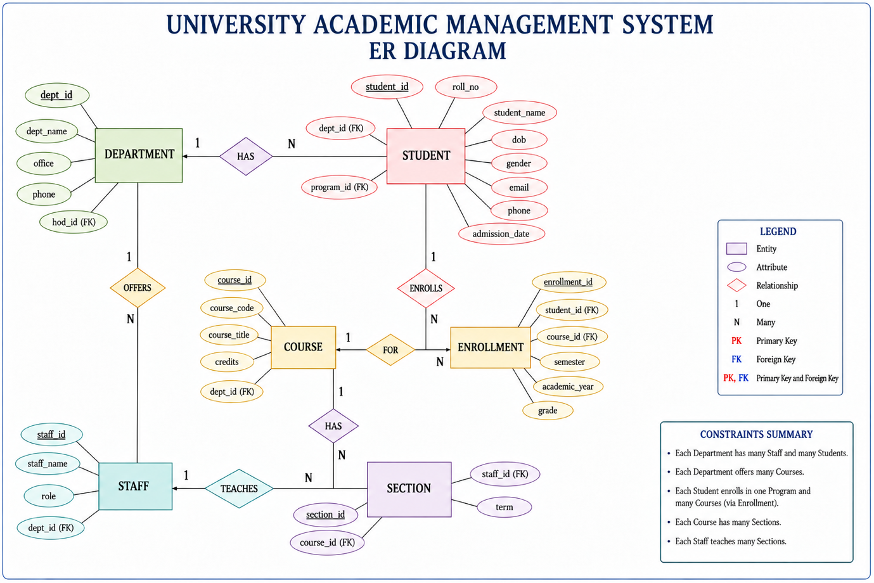
Figure 1. ER Diagram – University Academic Management System
The diagram shows the six entities, their attributes, primary keys (PK) and foreign keys (FK), and the cardinality of each relationship (1 = one, N = many).

5. RELATIONAL SCHEMA
Relation | Relational Schema
DEPARTMENT | department_id (PK), department_name, office
STUDENT | student_id (PK), student_name, email, major_id (FK → Department)
STAFF | staff_id (PK), staff_name, role, department_id (FK → Department), email
COURSE | course_code (PK), title, credits, department_id (FK → Department)
SECTION | section_id (PK), course_code (FK → Course), staff_id (FK → Staff), term, section_number, room
ENROLLMENT | enrollment_id (PK), student_id (FK → Student), course_code (FK → Course), grade, enroll_date; UNIQUE (student_id, course_code)

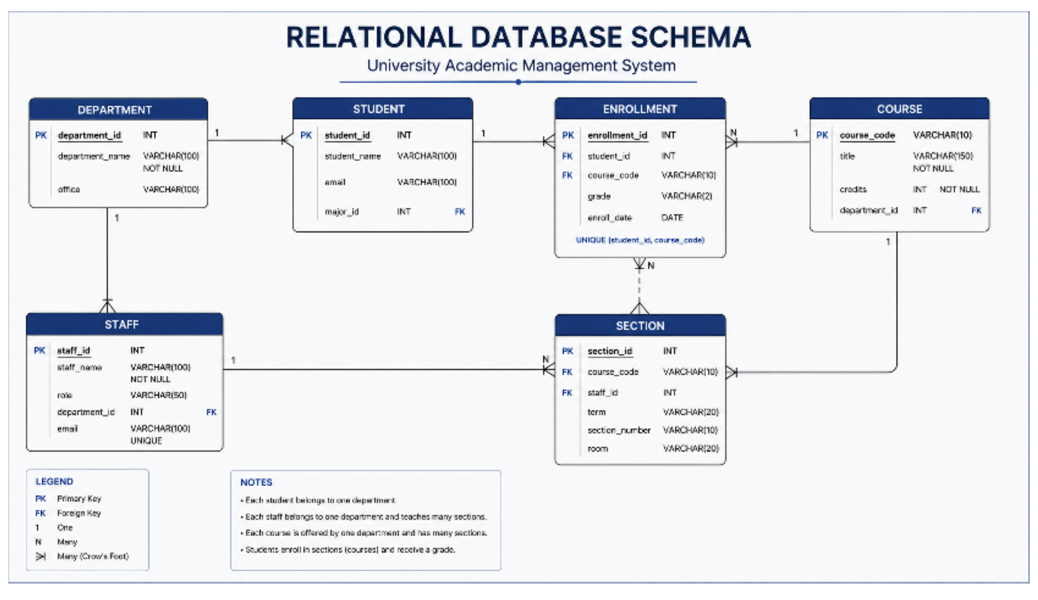
Figure 2. Relational Database Schema – University Academic Management System

6. TABLE DESIGN

6.1 Department Table
Attribute | Data Type | Constraint | Description
department_id | INT | PK, NOT NULL | Unique department identifier
department_name | VARCHAR(100) | NOT NULL | Name of the department
office | VARCHAR(100) | — | Department office / location
Table 3. Department Table Structure

6.2 Student Table
Attribute | Data Type | Constraint | Description
student_id | INT | PK, NOT NULL | Unique student identifier
student_name | VARCHAR(100) | NOT NULL | Full name of the student
email | VARCHAR(100) | UNIQUE | Student email address
major_id | INT | FK | References Department(department_id)
Table 4. Student Table Structure

6.3 Staff Table
Attribute | Data Type | Constraint | Description
staff_id | INT | PK, NOT NULL | Unique staff identifier
staff_name | VARCHAR(100) | NOT NULL | Full name of the staff member
role | VARCHAR(50) | — | Role / designation
department_id | INT | FK | References Department(department_id)
email | VARCHAR(100) | UNIQUE | Staff email address
Table 5. Staff Table Structure

6.4 Course Table
Attribute | Data Type | Constraint | Description
course_code | VARCHAR(10) | PK, NOT NULL | Unique course code
title | VARCHAR(150) | NOT NULL | Course title
credits | INT | NOT NULL, CHECK (> 0) | Credit value of the course
department_id | INT | FK | References Department(department_id)
Table 6. Course Table Structure

6.5 Section Table
Attribute | Data Type | Constraint | Description
section_id | INT | PK, NOT NULL | Unique section identifier
course_code | VARCHAR(10) | FK, NOT NULL | References Course(course_code)
staff_id | INT | FK | References Staff(staff_id); instructor of the section
term | VARCHAR(20) | — | Academic term (e.g. 2026-Fall)
section_number | VARCHAR(10) | — | Section number within the course
room | VARCHAR(20) | — | Room allotted to the section
Table 7. Section Table Structure

6.6 Enrollment Table
Attribute | Data Type | Constraint | Description
enrollment_id | INT | PK, NOT NULL | Unique enrolment identifier
student_id | INT | FK, NOT NULL | References Student(student_id)
course_code | VARCHAR(10) | FK, NOT NULL | References Course(course_code)
grade | VARCHAR(2) | — | Grade awarded to the student
enroll_date | DATE | — | Date of enrolment
Table 8. Enrollment Table Structure

6.7 Primary Keys and Foreign Keys
Table | Primary Key | Foreign Key(s)
Department | department_id | None
Student | student_id | major_id → Department(department_id)
Staff | staff_id | department_id → Department(department_id)
Course | course_code | department_id → Department(department_id)
Section | section_id | course_code → Course(course_code); staff_id → Staff(staff_id)
Enrollment | enrollment_id | student_id → Student(student_id); course_code → Course(course_code)
Table 9. Primary Keys and Foreign Keys

6.8 Other Constraints
Constraint | Applied To / Purpose
NOT NULL | department_name, student_name, staff_name, course title, credits, Section.course_code, Enrollment.student_id and course_code
UNIQUE | Student.email, Staff.email, and (student_id, course_code) in Enrollment to prevent duplicate enrolments
CHECK | Course.credits > 0
INDEX | Foreign-key columns are indexed to speed up joins and enrolment-count queries

7. NORMALIZATION
Normalization organizes data into related relations to reduce redundancy and update anomalies. The process below shows how the academic data is brought from an unnormalized record to Third Normal Form.

7.1 Unnormalized Form (UNF)
A single record may hold student_id, student_name, email, department_name, office and a repeating group of courses (course_code, title, credits), the instructor of each course, and the grade for each course. Repeating groups and repeated department and instructor details cause redundancy and anomalies.

7.2 First Normal Form (1NF)
Repeating groups are removed and every attribute holds an atomic value. Each student–course pair becomes its own row. Student, department and course details are still repeated across rows.

7.3 Second Normal Form (2NF)
Partial dependencies on the composite key (student_id, course_code) are removed. Student attributes depend only on student_id, course attributes only on course_code, and grade depends on the whole pair. This gives separate Student, Course and Enrollment relations.

7.4 Third Normal Form (3NF)
Transitive dependencies are removed. Department details (name, office) are stored once in Department and referenced by Student (major_id), Staff and Course. Instructor and term information is stored in Section, which references Course and Staff. Every non-key attribute now depends only on the key of its table.
Relation | Reason for Separation
Department | Stores department name and office once.
Student | Stores student-specific data with a reference to the major department.
Staff | Stores staff-specific data with a reference to the department.
Course | Stores course-specific data with a reference to the offering department.
Section | Stores a term-specific offering of a course and its instructor.
Enrollment | Stores the student–course registration and the grade.

8. SQL IMPLEMENTATION

8.1 DDL – Data Definition Language
The following DDL creates the six tables with their primary keys, foreign keys and constraints. Data types follow the relational schema and can be adjusted to the DBMS used.

CREATE DATABASE IF NOT EXISTS UniversityDB_Demo;
USE UniversityDB_Demo;

SELECT DATABASE();

USE UniversityDB_Demo;

CREATE TABLE Department (
department_id INT PRIMARY KEY,
department_name VARCHAR(100) NOT NULL,
office VARCHAR(100)
) ENGINE=InnoDB;

CREATE TABLE Student (
student_id INT PRIMARY KEY,
student_name VARCHAR(100) NOT NULL,
email VARCHAR(100) UNIQUE,
major_id INT,
CONSTRAINT fk_student_dept
FOREIGN KEY (major_id)
REFERENCES Department(department_id)
) ENGINE=InnoDB;

CREATE TABLE Staff (
staff_id INT PRIMARY KEY,
staff_name VARCHAR(100) NOT NULL,
role VARCHAR(50),
department_id INT,
email VARCHAR(100) UNIQUE,
CONSTRAINT fk_staff_dept
FOREIGN KEY (department_id)
REFERENCES Department(department_id)
) ENGINE=InnoDB;

CREATE TABLE Course (
course_code VARCHAR(10) PRIMARY KEY,
title VARCHAR(150) NOT NULL,
credits INT NOT NULL CHECK (credits > 0),
department_id INT,
CONSTRAINT fk_course_dept
FOREIGN KEY (department_id)
REFERENCES Department(department_id)
) ENGINE=InnoDB;

CREATE TABLE Section (
section_id INT PRIMARY KEY,
course_code VARCHAR(10) NOT NULL,
staff_id INT,
term VARCHAR(20),
section_number VARCHAR(10),
room VARCHAR(20),
CONSTRAINT fk_section_course
FOREIGN KEY (course_code)
REFERENCES Course(course_code),
CONSTRAINT fk_section_staff
FOREIGN KEY (staff_id)
REFERENCES Staff(staff_id)
) ENGINE=InnoDB;

CREATE TABLE Enrollment (
enrollment_id INT PRIMARY KEY,
student_id INT NOT NULL,
course_code VARCHAR(10) NOT NULL,
grade VARCHAR(2),
enroll_date DATE,
CONSTRAINT fk_enroll_student
FOREIGN KEY (student_id)
REFERENCES Student(student_id),
CONSTRAINT fk_enroll_course
FOREIGN KEY (course_code)
REFERENCES Course(course_code),
CONSTRAINT uq_student_course
UNIQUE (student_id, course_code)
) ENGINE=InnoDB;

SHOW TABLES;

8.2 Indexes
USE UniversityDB_Demo;

CREATE INDEX idx_student_major
ON Student(major_id);

CREATE INDEX idx_staff_dept
ON Staff(department_id);

CREATE INDEX idx_course_dept
ON Course(department_id);

CREATE INDEX idx_section_course
ON Section(course_code);

CREATE INDEX idx_section_staff
ON Section(staff_id);

CREATE INDEX idx_enroll_student
ON Enrollment(student_id);

CREATE INDEX idx_enroll_course
ON Enrollment(course_code);

SHOW INDEX FROM Student;
SHOW INDEX FROM Enrollment;

8.3 DML – Seed Data
A minimal seed dataset used to validate the workflows. Names and values are sample data.
USE UniversityDB_Demo;

INSERT INTO Department
(department_id, department_name, office)
VALUES
(1, 'Artificial Intelligence and Machine Learning', 'Block A - 201'),
(2, 'Computer Science', 'Block B - 105'),
(3, 'Mathematics', 'Block C - 110');

INSERT INTO Student
(student_id, student_name, email, major_id)
VALUES
(101, 'Student One', 'student1@example.edu', 1),
(102, 'Student Two', 'student2@example.edu', 1),
(103, 'Student Three', 'student3@example.edu', 2),
(104, 'Student Four', 'student4@example.edu', 2),
(105, 'Student Five', 'student5@example.edu', 3);

INSERT INTO Staff
(staff_id, staff_name, role, department_id, email)
VALUES
(201, 'Staff One', 'Professor', 1, 'staff1@example.edu'),
(202, 'Staff Two', 'Assistant Professor', 2, 'staff2@example.edu'),
(203, 'Staff Three', 'Associate Professor', 3, 'staff3@example.edu');

INSERT INTO Course
(course_code, title, credits, department_id)
VALUES
('AI101', 'Introduction to AI', 4, 1),
('DB201', 'Database Management Systems', 4, 2),
('CS301', 'Data Structures', 3, 2),
('MA101', 'Discrete Mathematics', 3, 3);

INSERT INTO Section
(section_id, course_code, staff_id, term, section_number, room)
VALUES
(1, 'AI101', 201, '2026-Fall', 'A', 'R-101'),
(2, 'DB201', 202, '2026-Fall', 'A', 'R-102'),
(3, 'CS301', 202, '2026-Fall', 'B', 'R-103'),
(4, 'MA101', 203, '2026-Fall', 'A', 'R-104');

INSERT INTO Enrollment
(enrollment_id, student_id, course_code, grade, enroll_date)
VALUES
(1, 101, 'AI101', 'A', '2026-07-15'),
(2, 101, 'DB201', 'B+', '2026-07-15'),
(3, 102, 'DB201', 'A', '2026-07-16'),
(4, 103, 'CS301', 'B', '2026-07-16'),
(5, 104, 'DB201', NULL, '2026-07-17'),
(6, 105, 'MA101', 'A-', '2026-07-17');

SELECT 'Department' AS table_name, COUNT(*) AS total FROM Department
UNION ALL
SELECT 'Student', COUNT(*) FROM Student
UNION ALL
SELECT 'Staff', COUNT(*) FROM Staff
UNION ALL
SELECT 'Course', COUNT(*) FROM Course
UNION ALL
SELECT 'Section', COUNT(*) FROM Section
UNION ALL
SELECT 'Enrollment', COUNT(*) FROM Enrollment;

9. SQL QUERIES & SCREENSHOTS
The queries below cover selection, filtering, joins, aggregation, subqueries, updates and deletion, and validate the enrolment, grading and reporting workflows. Paste the screenshot of each output in the placeholder after running the query on the seed data.
Q1. Display all departments
SELECT * FROM Department;
Output:
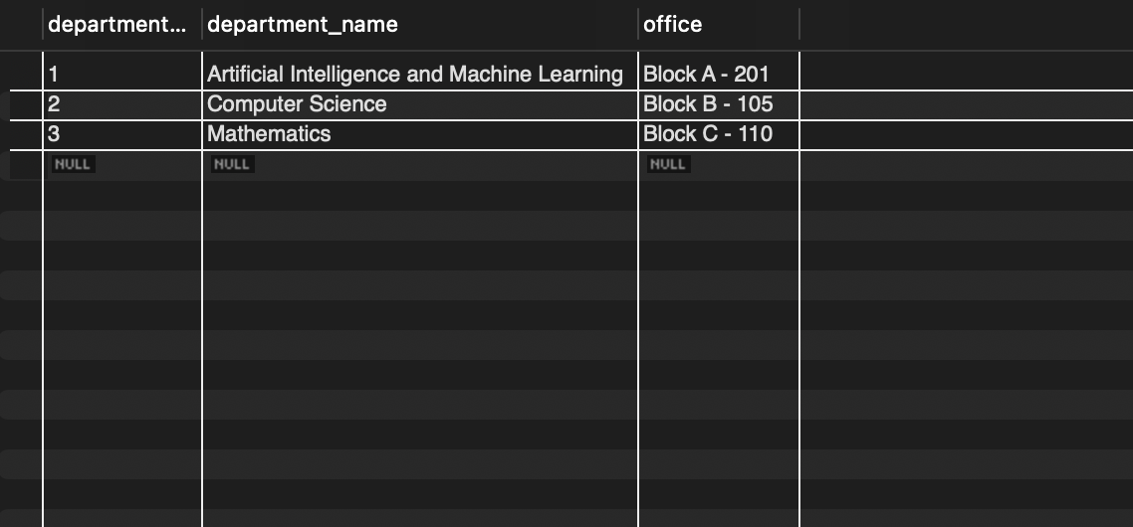
Q2. Display all students
SELECT * FROM Student;
Output:
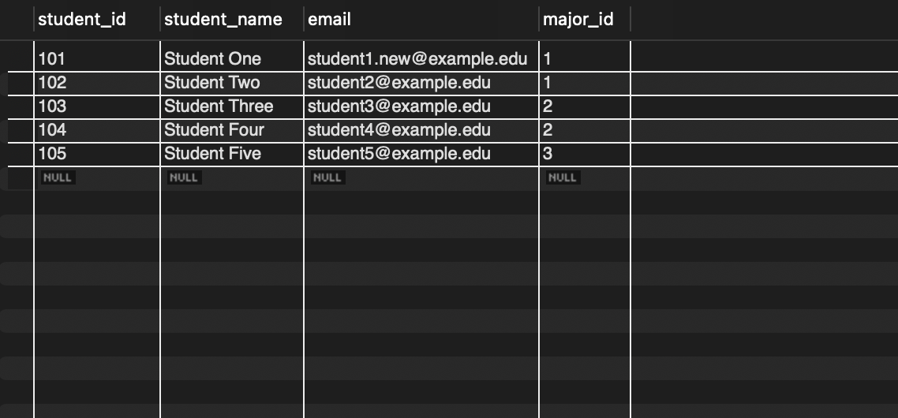
Q3. Display all staff members
SELECT * FROM Staff;
Output:
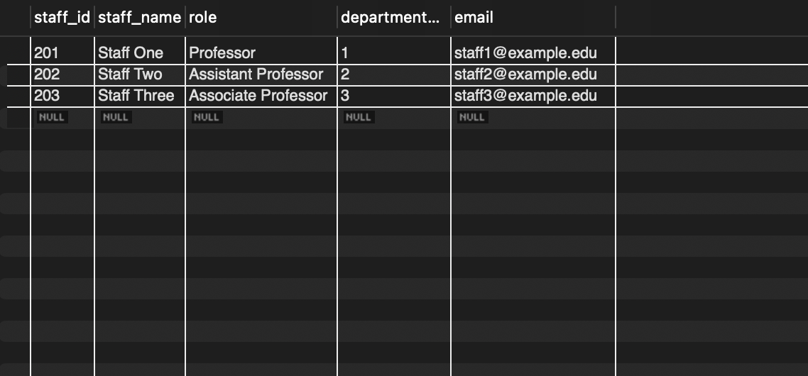
Q4. Display all courses
SELECT * FROM Course;
Output:
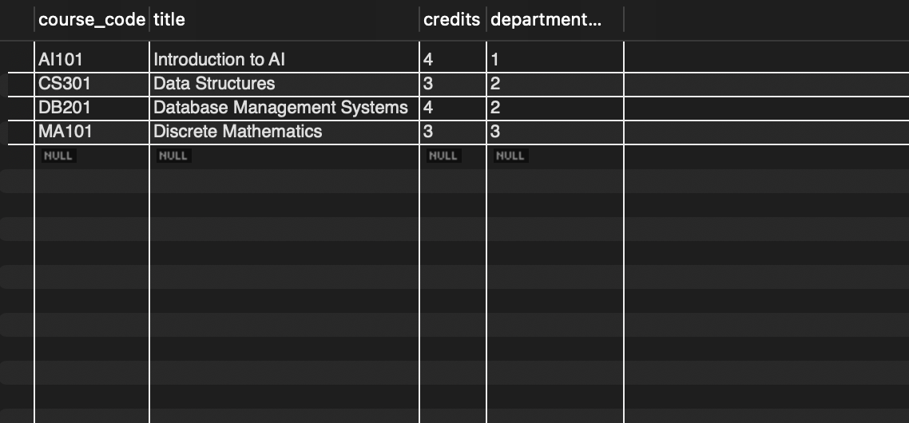
Q5. Display all sections
SELECT * FROM Section;
Output:
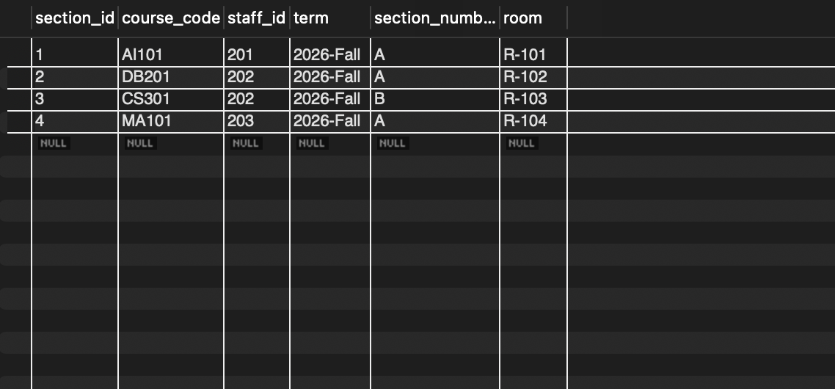
Q6. Display all enrollments
SELECT * FROM Enrollment;
Output:
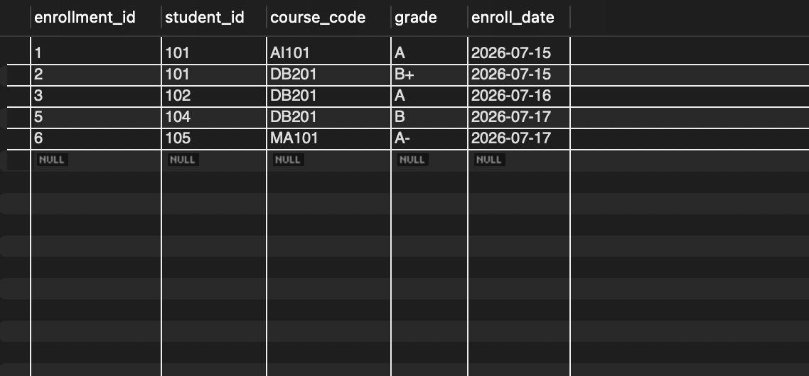
Q7. Students of a given department (major)
SELECT student_id, student_name, email
FROM Student
WHERE major_id = 1;
Output:
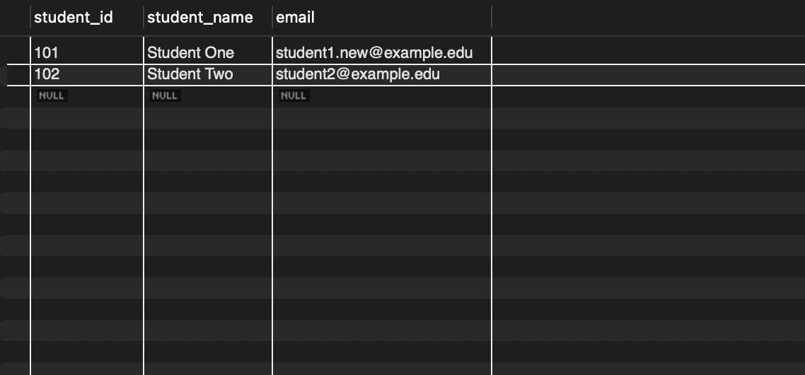
Q8. Courses ordered by title
SELECT course_code, title, credits
FROM Course
ORDER BY title ASC;
Output:
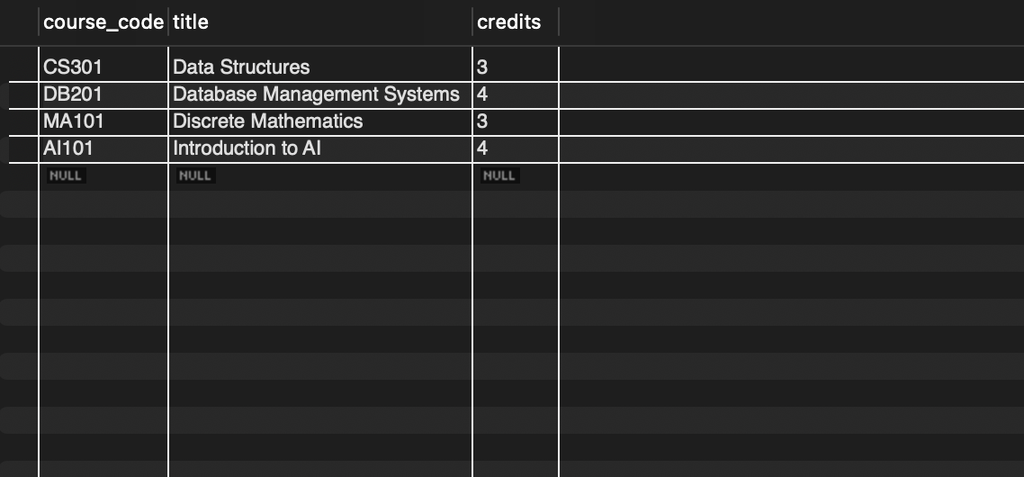
Q9. Students with their department names
SELECT s.student_id, s.student_name, d.department_name
FROM Student s
INNER JOIN Department d
ON s.major_id = d.department_id;

Output:
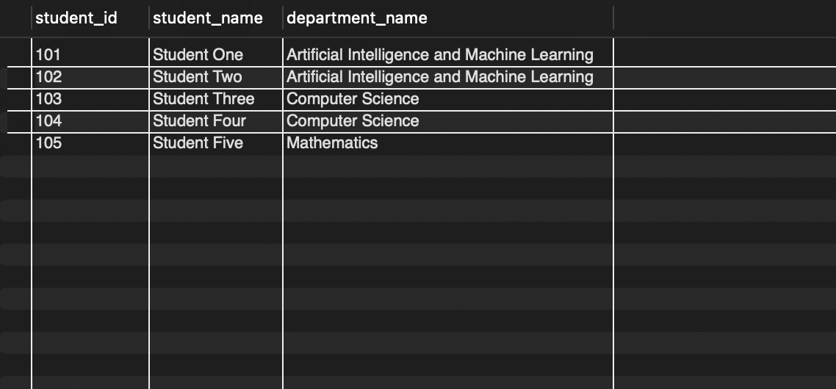
Q10. Staff with their department names
SELECT st.staff_id, st.staff_name, st.role,
d.department_name
FROM Staff st, Department d
WHERE st.department_id = d.department_id;
Output:
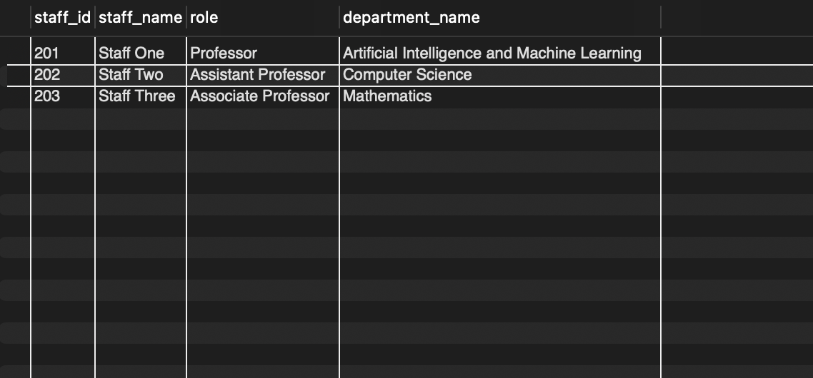
Q11. Courses offered by each department
SELECT department_name, course_code, title, credits
FROM Course
NATURAL JOIN Department;
Output:
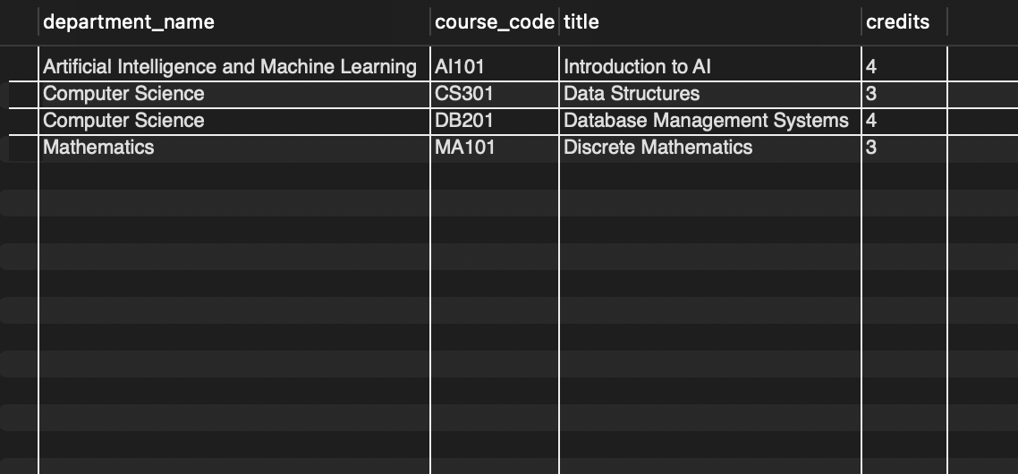
Q12. All departments and their students
SELECT d.department_name, s.student_id, s.student_name
FROM Department d
LEFT JOIN Student s
ON d.department_id = s.major_id;
Output:
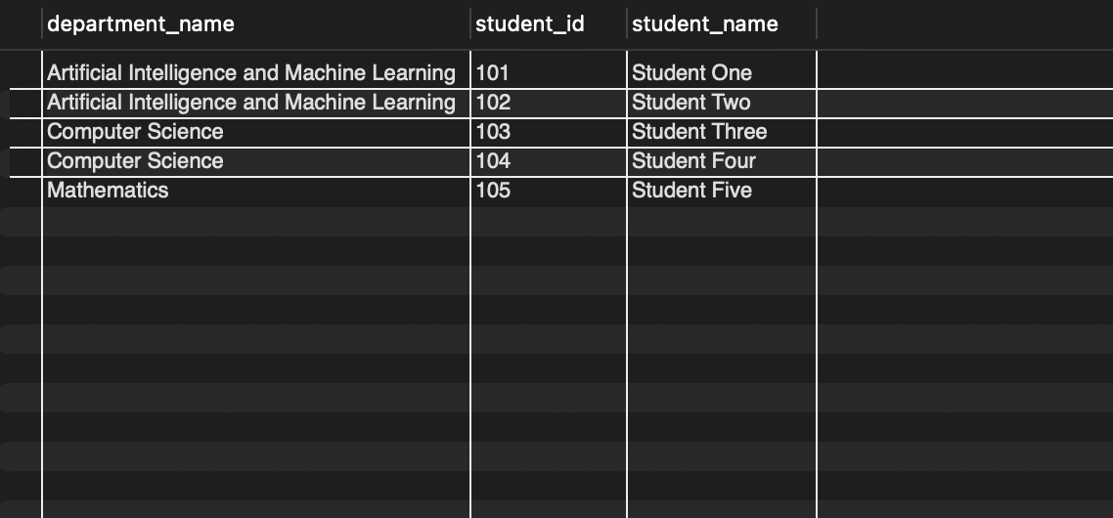
Q13. All courses and their departments
SELECT c.course_code, c.title, d.department_name
FROM Department d
RIGHT JOIN Course c
ON d.department_id = c.department_id;
Output:
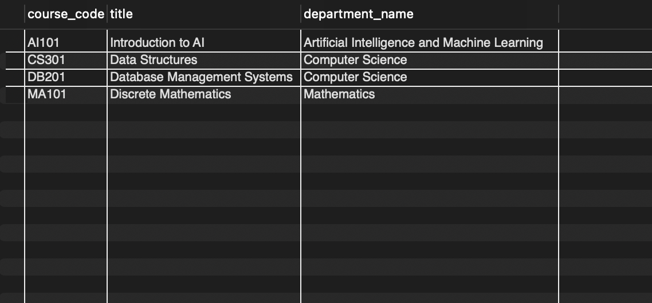
Q14. All departments and staff
SELECT d.department_id, d.department_name,
st.staff_id, st.staff_name
FROM Department d
LEFT JOIN Staff st
ON d.department_id = st.department_id

UNION ALL

SELECT d.department_id, d.department_name,
st.staff_id, st.staff_name
FROM Department d
RIGHT JOIN Staff st
ON d.department_id = st.department_id
WHERE d.department_id IS NULL;
Output:
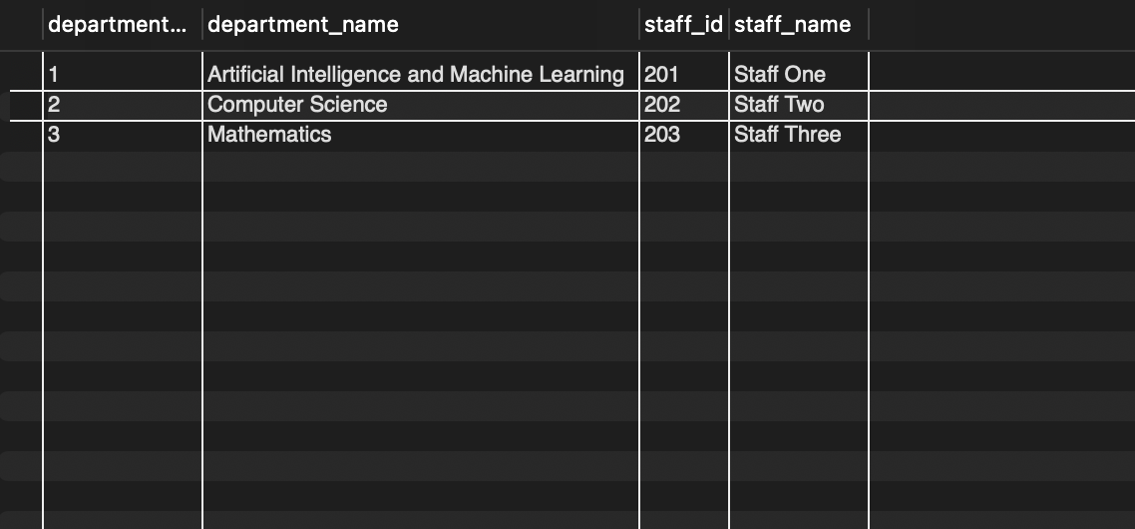
Q15. Number of students per department
SELECT d.department_name,
COUNT(s.student_id) AS total_students
FROM Department d
LEFT JOIN Student s
ON d.department_id = s.major_id
GROUP BY d.department_id, d.department_name;
Output:
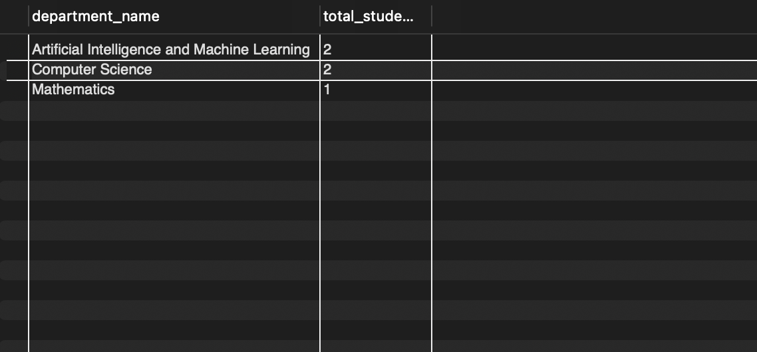
Q16. Number of enrolments per course
SELECT c.course_code, c.title,
COUNT(e.enrollment_id) AS total_enrolled
FROM Course c
LEFT JOIN Enrollment e
ON c.course_code = e.course_code
GROUP BY c.course_code, c.title;
Output:
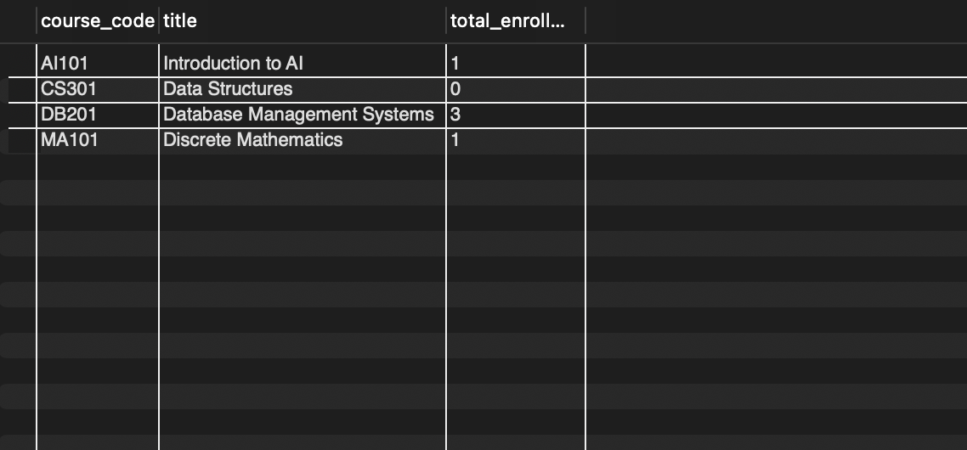
Q17. Number of sections taught by each staff member

SELECT st.staff_name,
COUNT(sec.section_id) AS sections_taught
FROM Staff st
LEFT JOIN Section sec
ON st.staff_id = sec.staff_id
GROUP BY st.staff_id, st.staff_name;
Output:
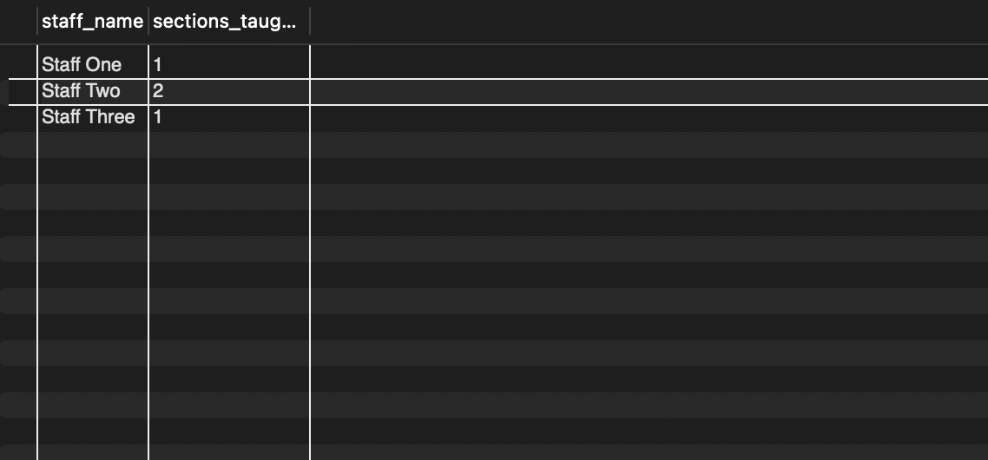
Q18. Total credits registered by each student
SELECT s.student_id, s.student_name,
SUM(c.credits) AS total_credits
FROM Student s
JOIN Enrollment e
ON s.student_id = e.student_id
JOIN Course c
ON e.course_code = c.course_code
GROUP BY s.student_id, s.student_name;
Output:
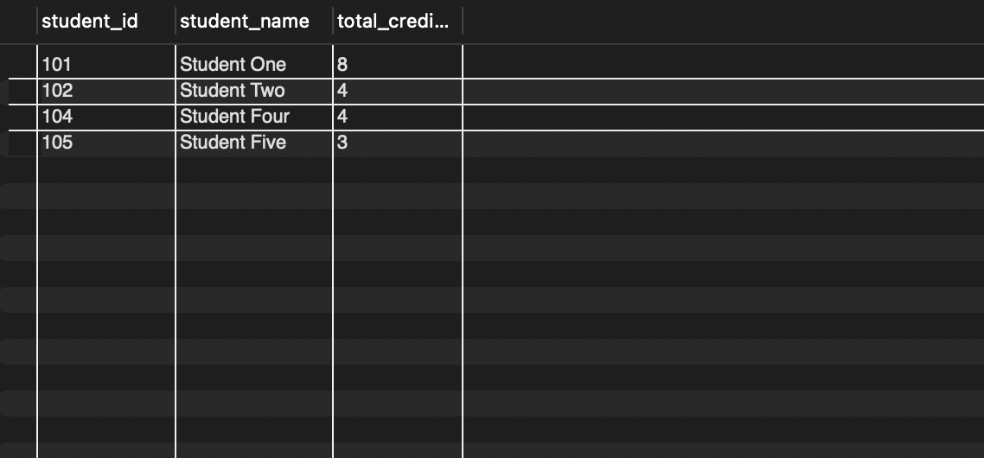
Q19. Departments offering more than one course
SELECT d.department_name,
COUNT(c.course_code) AS total_courses
FROM Department d
JOIN Course c
ON d.department_id = c.department_id
GROUP BY d.department_id, d.department_name
HAVING COUNT(c.course_code) > 1;
Output:
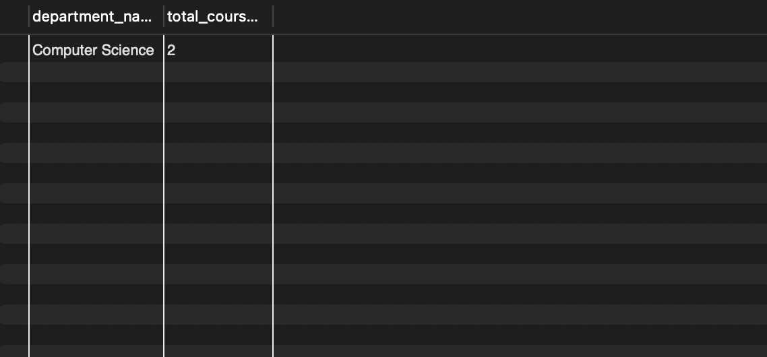
Q20. Average course credits
SELECT AVG(credits) AS average_credits
FROM Course;
Output:
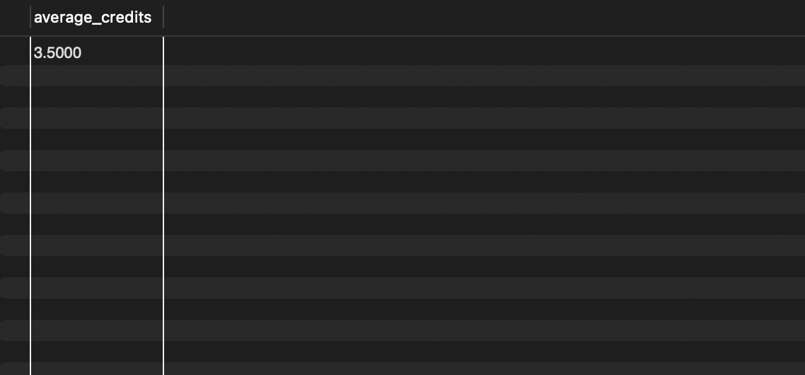
Q21. Students who received grade A
SELECT student_id, student_name
FROM Student
WHERE student_id IN (
SELECT student_id
FROM Enrollment
WHERE grade = 'A'
);
Output:
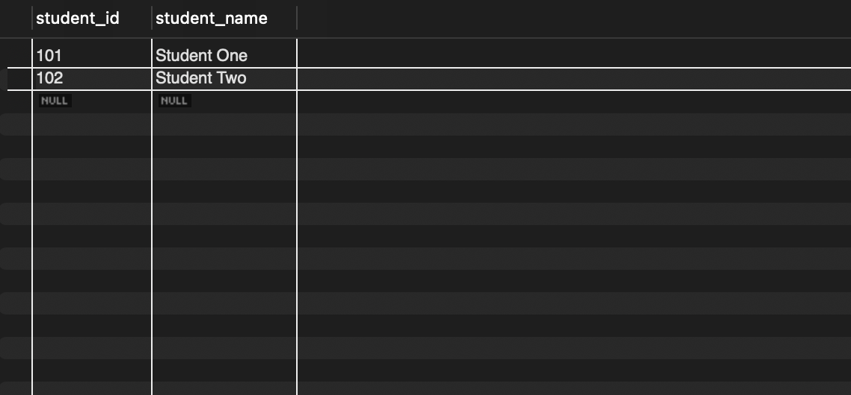
Q22. Students not enrolled in any course
SELECT s.student_id, s.student_name
FROM Student s
WHERE NOT EXISTS (
SELECT 1
FROM Enrollment e
WHERE e.student_id = s.student_id
);
Output:
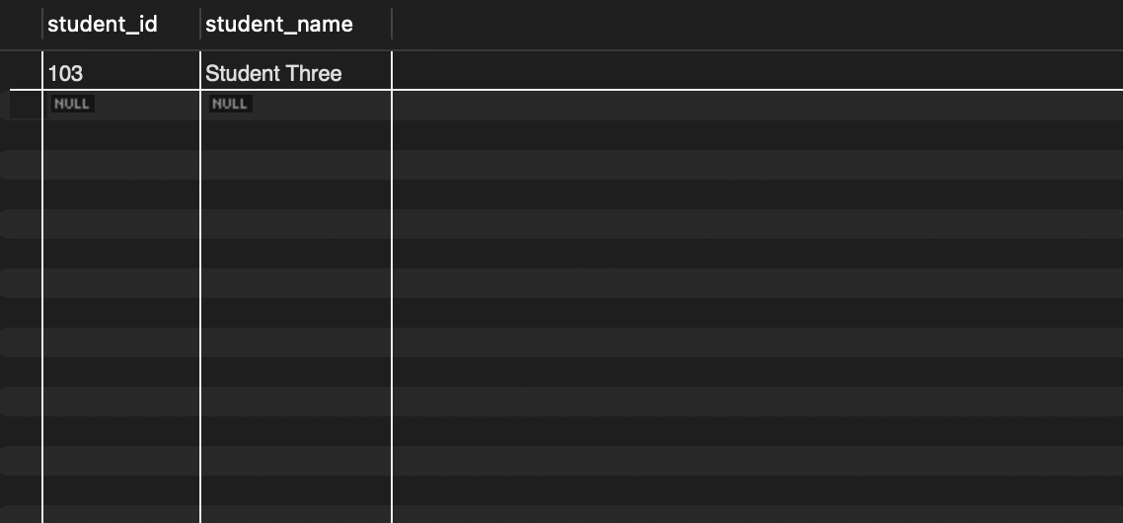
Q23. Courses with no enrolments
SELECT c.course_code, c.title
FROM Course c
WHERE NOT EXISTS (
SELECT 1
FROM Enrollment e
WHERE e.course_code = c.course_code
);
Output:
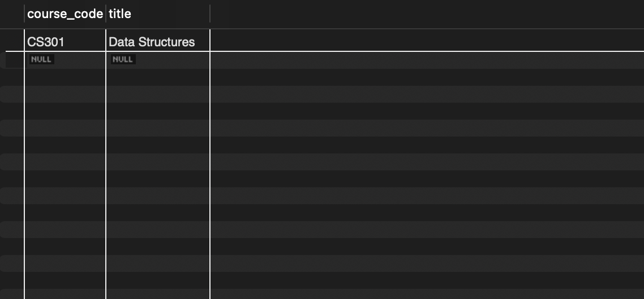
Q24. Courses with enrolments above the average
SELECT c.course_code, c.title,
COUNT(e.enrollment_id) AS total_enrolled
FROM Course c
LEFT JOIN Enrollment e
ON c.course_code = e.course_code
GROUP BY c.course_code, c.title
HAVING COUNT(e.enrollment_id) > (
SELECT AVG(course_total)
FROM (
SELECT COUNT(*) AS course_total
FROM Enrollment
GROUP BY course_code
) AS avg_data
);
Output:
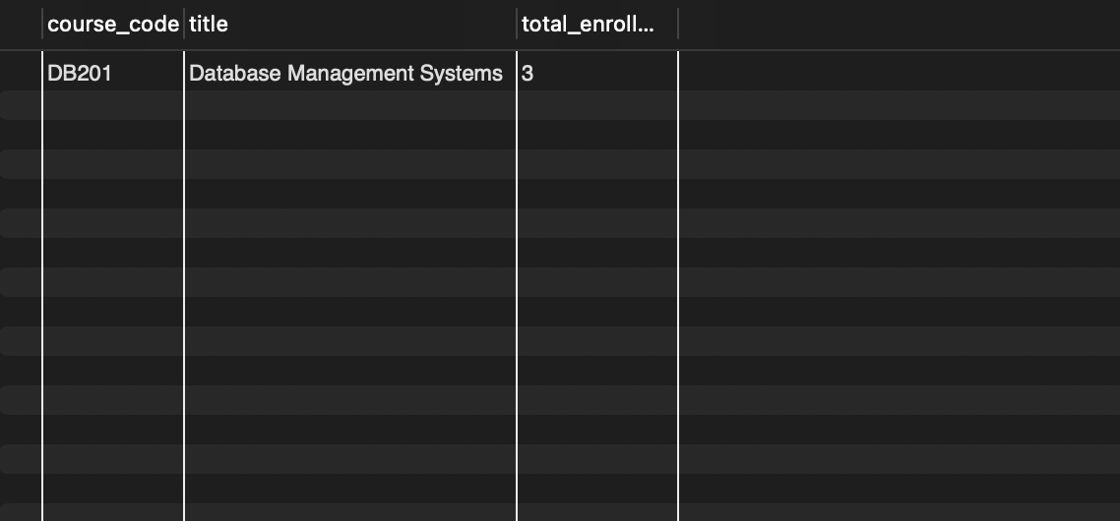
Q25. Students enrolled in the same courses as student 101
SELECT DISTINCT s.student_id, s.student_name
FROM Student s
JOIN Enrollment e
ON s.student_id = e.student_id
WHERE e.course_code IN (
SELECT course_code
FROM Enrollment
WHERE student_id = 101
)
AND s.student_id <> 101;
Output:
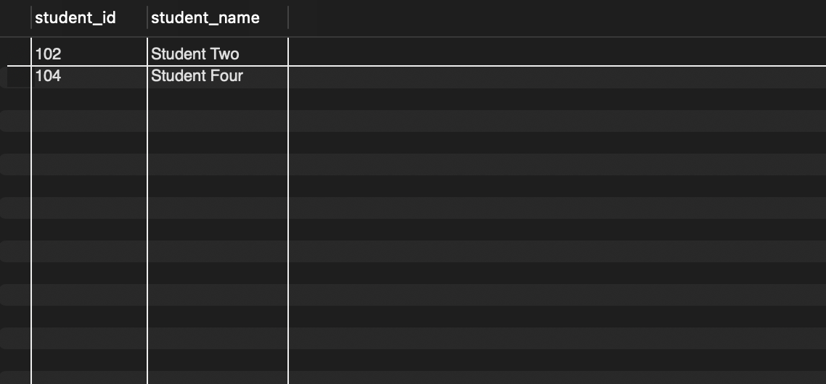
Q26. Students enrolled in at least two courses
SELECT s.student_id, s.student_name
FROM Student s
WHERE (
SELECT COUNT(*)
FROM Enrollment e
WHERE e.student_id = s.student_id
) >= 2;
Output:
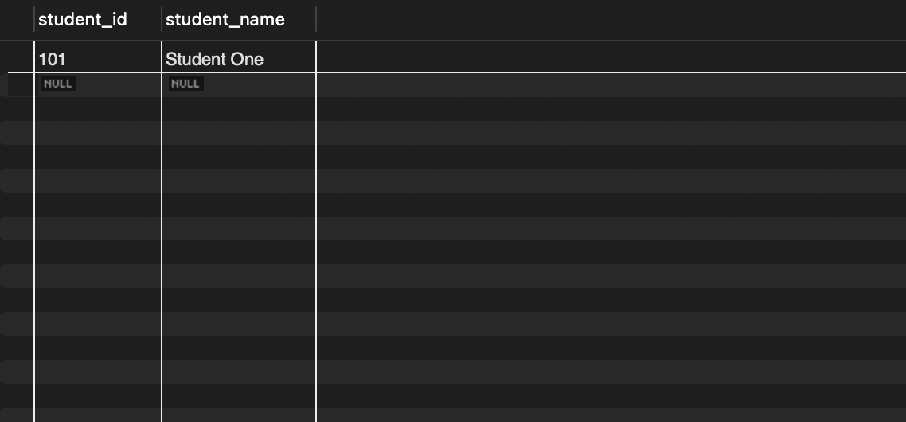
Q27. Create an updatable view of student details
SELECT DISTINCT s.student_name
CREATE VIEW StudentBasicView AS
SELECT student_id, student_name, email, major_id
FROM Student;
Output:
Q28. Display the view
SELECT * FROM StudentBasicView;
Output:
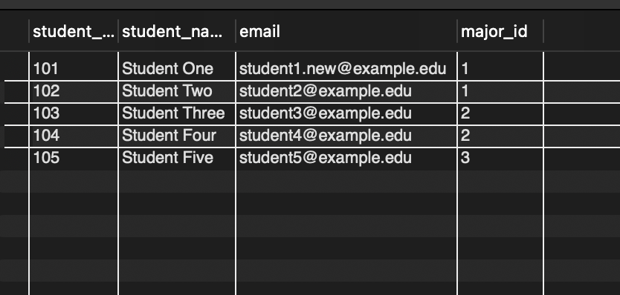
Q29. Create a non-updatable view showing department student counts
CREATE VIEW DepartmentStudentCount AS
SELECT d.department_name,
COUNT(s.student_id) AS total_students
FROM Department d
LEFT JOIN Student s
ON d.department_id = s.major_id
GROUP BY d.department_id, d.department_name;
Output:
Q30. Display the view
SELECT * FROM DepartmentStudentCount;
Output:
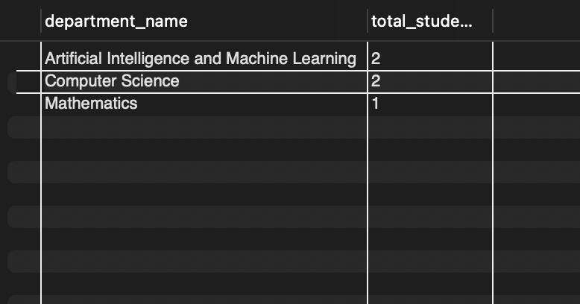

10. GITHUB REPOSITORY AND TEAM MEMBER RESPONSIBILITIES

10.1 GitHub Repository
All project artefacts — the ER diagram, relational schema, SQL DDL with indexes, seed data, sample queries and migration steps — are maintained in the team’s GitHub repository.
Item | Details
Repository URL | https://github.com/subhashneelamsetti-2025/University-Academic-Management-System
Suggested structure | docs/ (ER diagram, schema, report), sql/schema.sql, sql/indexes.sql, sql/seed.sql, sql/queries.sql, README.md
Migration steps | 1. Run schema.sql 2. Run indexes.sql 3. Run seed.sql 4. Run queries.sql to validate

10.2 Team Member Responsibilities
Name | Roll Number | Responsibility
A. Pavan Kumar Reddy | 25B11AI052 | [ Requirements and entity identification ]
G. Nikhilesh Varma | 25B11AI305 | [ ER diagram and relationships ]
M. Revanth Yadav | 25B11AI670 | [ Relational schema, keys and normalization ]
N. Subhash | 25B11AI835 | [ SQL DDL, seed data, queries and GitHub ]
Table 10. Team Member Responsibilities

11. CONCLUSION
The University Academic Management database provides a structured replacement for fragmented spreadsheets and legacy systems. Its six related tables — Department, Student, Staff, Course, Section and Enrollment — are connected by primary and foreign keys and protected by NOT NULL, UNIQUE and CHECK constraints, which prevents duplicate and inconsistent records. The design is normalized to 3NF, indexed for query performance, and validated with a seed dataset and sample queries. The project therefore meets the stated objectives and offers a sound base for extending the system with payroll, audit logging and application interfaces.

12. FUTURE ENHANCEMENTS
- Payroll tables (salary, allowances, deductions) linked to Staff to automate payroll calculations.
- Audit-log tables and triggers to record administrative changes.
- Course prerequisite table to enforce prerequisites during registration.
- Role-based access for administrators, staff and students.
- Attendance, fee and timetable management.
- Report dashboards and web or mobile front ends.

REFERENCES
- Korth, H. F., Silberschatz, A., and Sudarshan, S., Database System Concepts, McGraw Hill.
- Elmasri, R. and Navathe, S. B., Fundamentals of Database Systems, Pearson.

